ATTENTION !
TIGER CUB, WOLF AND BEAR DENS
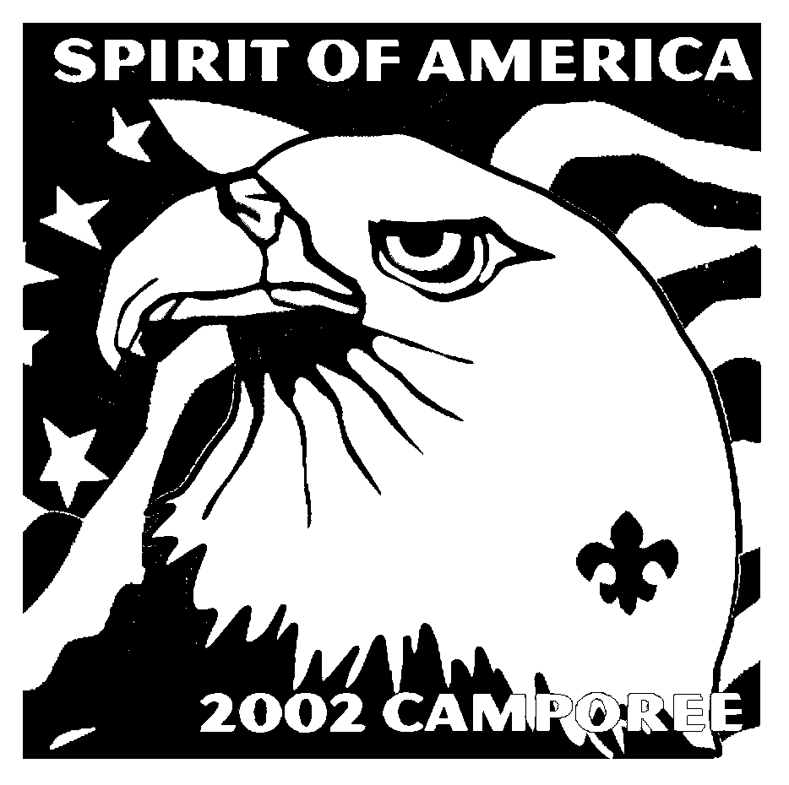
You are invited to Pomo District 2002 Camporee for Cubs

2002 Pomo District Camporee of Cubs Registration Form
(Fill out one form per Den attending)
Please return this form and payment into the Council Service Center as soon as possible. Attach additional sheets if necessary.
CAMPOREE WILL BE HELD RAIN OR SHINE.
Pack #____________________District____________________

Name of Den Leader attending Camporee_______________________________________________
Address_______________________________________________________________________
City/Zip_______________________________________________________________________
Day Phone_________________________Evening Phone_________________________

Registration Fees:
Number of Adults_________ x $4.00 = $__________
Number of Scouts_________ x $4.00 = $__________
Discount Total ___________ x $1.00 = $__________ (If registration paid by April 13th)
Total Amount enclosed = $_________
(Only scouts and adults that have paid and registered for this event will receive a patch.)
Den Name__________________________________
Name of Registered Boys
Boy #1 __________________________________________________
Boy #2 __________________________________________________
Boy #3 __________________________________________________
Boy #4 __________________________________________________
Boy #5 __________________________________________________
Boy #6 __________________________________________________
Boy #7 __________________________________________________
Boy #8 __________________________________________________
Name of Registered Adults
Adult #1 _________________________________________________
Adult #2 _________________________________________________
Adult #3 _________________________________________________

Please list non registered adults attending:
_________________________________________________________
_________________________________________________________
_________________________________________________________
_________________________________________________________
_________________________________________________________

PLEASE TURN THIS FORM AND PAYMENT TO:
REDWOOD EMPIRE COUNCIL, 2240 PROFESSIONAL DRIVE
SANTA ROSA, CA 95403.

Patches issued: Scouts ____________Adults____________ Event CODE: 6204

WHERE: Lake Sonoma

WHEN: May 4, 2002
9:00am - Mid afternoon
RAIN OR SHINE
COST: $4.00 per person
You will receive
a $1 per person discount,
for registrations before April 13th.
NOTE: Only Registered participants will receive a participants patch.
Plan early.
Pre-Registrations are a MUST!
Do not plan on registering at the event!

DIRECTIONS TO THE CAMPOREE:
Take Hwy. 101, north toward Healdsburg. Take the Dry Creek Rd. off ramp and go west on Dry Creek Rd. You will travel about 9 miles to Lake Sonoma.

Pomo District
2002 Camporee for Cubs

Saturday May 4, 2002
Lake Sonoma
Leaders Guide

Pomo District Camporee Staff is offering a brand new event, and inviting Cub Scout Dens to have a day of fun at Camporee. This will be a great opportunity for Cub Scouts and Boy Scouts of the Pomo District to observe one another in action as they both compete in events that show off their knowledge of their scouting skills. You won’t want to miss this!! All Cub Scout Pack are encouraged to have their Dens participate in this event.
So, begin your preparations now! Hone your Scout skills, so you will compete well. "Be Prepared" for an exciting day!
If you have any questions, please feel free to contact me.
John Chavez,
Camporee for Cubs Coordinator
620-0774
Information you will need to know about
Camporee for Cubs

The District Camporee purpose is to bring together all Scouts, from Tigers to Eagle, and their leaders for a combined experience at which Scouts:

• Demonstrate and share proficiency in basic Scouting skills
• Master new skills.
• Interact with other Scouting units.
• Attain a district-wide perspective and fellowship.
• Most importantly, to move forward in Scouting.

What to do Today

1. Read this Guidebook

2. Fill out and return the registration form and fee.

3. Put this event on your program calendar

4. Plan now to prepare your unit for effective participation

5. Plan on having fun in May and collecting another super collectable patch for each REGISTERED participant.

General Information

Location -- The 2002 Camporee for Cubs will be held at Lake Sonoma Warm Springs Recreation Area. Please refer to the directions in this packet. Please remember that our behavior reflects upon the entire organization, and counsel your Scouts accordingly. The Army Corp of Engineers has graciously allowed us to hold our Camporee in this area with the express understanding that we will obey the rules and behave as GOOD Scouts. REMEMBER the Scout Oath, Law and Promises prevail at all times.

Registration and Fees -- Registration is open to all registered Cub Scout Dens in our District. The cost for Cub Scouts, and Registered Scouting adults participating is $4.00 per participant. (you will receive a $1.00 per participant discount, if you register before April 19th, please take advantage of this, as we like to encourage early registration). This fee covers the ribbons, insurance, event supplies, miscellaneous expenses, and the special event patch - (This will be the 5th edition Peanuts Comic Strip patch).

Patrol/Den Size -- The size of each den should be 6 to 8 Cubs. If not enough scouts from the regularly formed den attend, a temporary grouping of 6 to 8 Scouts should be organized specifically for the event.

NOTE: UNIT LEADERS are responsible for monitoring Cubs at ALL TIMES.

General Instructions, Rules and Regulations

Food and water - Every Den/Scout is responsible to bring their own group or individual lunch and snacks. Also be sure that every participant has a water bottle. There will be places for water re-fills. Also: don’t forget the sun screen.

Sanitary Facilities -- Please use the latrine facilities provided by the park.

First Aid -- First Aid treatment is available at the First Aid Station located near the Camporee headquarters. All injuries and illnesses must be reported to the First Aid station, no matter how minor they may appear as they must be entered into the First Aid log.

Parking - Parking will be limited, so PLEASE plan on car-pooling. Look for the designated parking lot.

Restricted AREA’s - Several restricted areas exist within the Park. All Park rules should be strictly observed.

Judging Criteria and Awards

Den awards -- Each Den will be issued a score sheet to carry during the competition events. A maximum of 100 points can be earned for each event. Points are awarded based on objective criteria for the most part. The duty of the den leaders is to fill in the identifying information on the card and retain the record. The scorecard will be updated after each event. This card will be the official record of the scores earned. It will be collected by a Camporee staff member when the events are completed. The den must take part in all scheduled events on the scorecard in order to achieve the basic award.
Awards will be given to the top three Cub Scout Dens.

Q&A

Does it have to be "one parent per Cub", or can I bring the whole family? Even though Scouting is a family activity due to location we don’t have room for the “whole family” to attend. However we encourage you to bring one parent per Cub to Camporee. This is a must for Tiger Dens, as their program is Cub/parent.

Preliminary Schedule and Events*

Schedule for Saturday, May 4, 2002

9:00-9:30 am Arriving Packs Register - Camp Office
“Camporee for Cubs” Leaders meet at (Location T.B.A.)
Dens Participating in “Camporee for Cubs” Registration -- (Location T.B.A.)

9:30-10:00 am “Camporee for Cubs” Events begin (Location T.B.A.)

12 Noon Lunch

1:00 pm “Camporee for Cubs” Activities continue

4:00 pm Cub, Webelos and Scout events conclude

Remember: Unit Leaders are responsible for monitoring Cub Scouts activities.

The Cub Events*
(All events are timed to determine participants score)

1 -- Law/Promise (100 Points)
Unscramble the law and promise.

2 -- Uniform (100 Points)
Place the patches where they are supposed to go on a Cub Scout uniform.

3 -- Kim’s Game (100 Points)
Identify and recall objects from memory.

4 -- Flag Folding (100 Points)
Properly fold the US Flag.

5 -- Tool Identification (100 Points)
Properly identify a whole bunch of common tools.

6 -- Folklore Match (100 Points)
Unscramble American folklore people, places and things.

7 -- Obstacle Course (100 Points)
A test of physical ability,

8 -- Knot Tying Relay (100 Points)
Tie all the knots in the Webelos handbook.

9 -- Island Rescue (100 Points)
Save a Scout stranded on an island, by tying together short pieces of rope, and tossing him the rope. He must then tie a bowline around himself to be pulled to safety.

10 -Foot Racer (100 Points)
A test of balance and agility.

* subject to change with or without notice

